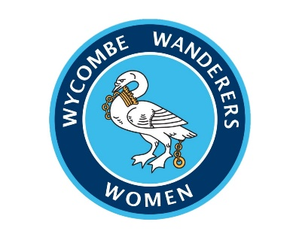October 2023 newsletter

Welcome to the October newsletter of the 2023/24 season. Thank you all for your continued support. It’s been a busy month so read on to find out what’s been going on…

In case you missed it… recent results
October results
First Team:
Sun 1st Oct : Ascot United 0 – Wycombe 1 (FA Cup First Round)
Sun 8th Oct: Wycombe 1 - Badshot Lea 0
Sun 15th Oct: Wycombe 2 – Penn & Tylers Green 1
Sun 22nd Oct: Dartford 8 – Wycombe 1
Sun 29th Oct: Woodley – Wycombe POSTPONED DUE TO WEATHER

Under 23’s
Sun 1st Oct: Eversley & California 0 – Wycombe 5
Sun 8th Oct: Long Crendon 1 – Wycombe 2
Sun 29th Oct: Wycombe 3 – Penn & Tylers Green 2

Under 18’s:
Sat 7th Oct: Wycombe 1 – Millwall 7
Sat 14th Oct: Wycombe 2 – AFC Miami Belles 1 (Berks & Bucks Cup)
Sat 21st Oct: Wycombe 3 – Kew Park Rangers 3
Sat 28th Oct: Wycombe 3 – Nottingham Forest 0 (First JPL League game)

Mascots
This season, the Chairgirls are pleased to offer mascot packages to young supporters who visit us at The 1878 Stadium. Recently, we have welcomed Downley Dynamos U11s and Harefield United Girls.
A big thank you to our groups that have come down so far and we look forward to hosting more groups in the future.
Our mascot package includes a mini warm up on the pitch, walk out onto the pitch with the Chairgirls just before kick off and 2 FREE adult/group leader tickets.
If you know anyone that might be interested in a mascot package, please do pass on my email (Emily.jane123@yahoo.co.uk) to them and I am happy to help organise a mascot experience for them.

OWWSA AGM- Emily talks to members
On Thursday 19th October Chairgirls Ambassador ,Emily Isaac, attended the OWWSA (Official Wycombe Wanderers Supporters Association) AGM. At the event, Emily spoke to members about the Women’s team; where they play, who’s who, experiences etc. Lots of interesting questions were asked as we spread the word on the Women’s team. Emily also took the opportunity to thank OWWSA for their continued support to the Women’s team as they sponsor the team again this season.

Player of the match
Once again this season, our first team coaching staff will be awarding player of the match after every fixture.
Our October match winners were…
- Emily McCartney v Ascot
- Chelsea Coles v Badshot Lea
- Katie Riddington v Penn and Tylers Green
- Emily McCartney v Dartford

Tables

Firsts:

U23s:
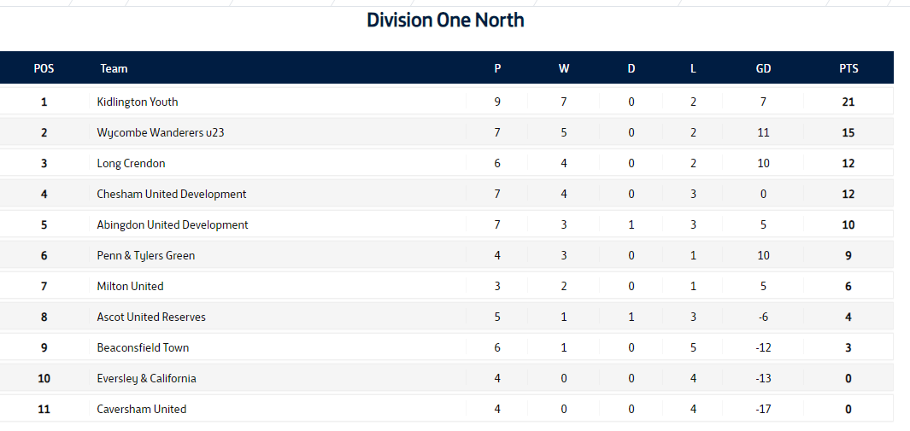

U18s:

U23s season
The U23s continue to go from strength to strength under new manager Ian Beckford. They currently sit 2nd in the Division One North with 15 points on the board so far.
S Read netted a hattrick against Penn & Tylers Green as they went on to win 3-2 in a hard fought win. Next up for the U23s, they travel to Milton United in the hunt for hopefully another 3 points.

U18s semi-final date for Berks and Bucks Cup
Our semi-final fixture has been confirmed! The young Chairgirls will face Wantage Town Girls. This game is being played on Saturday 11th November, 10.30am kick off at The 1878 Stadium, Wymers Wood Road, SL1 8JG.
U18s season
The new league season has just commenced for the young Chairgirls. The U18s squad are a part of the Junior Premier League.
The first league game for the U18s was played at home to Nottingham Forest on Saturday 28th October. They won 3-0 with goals from P Lloyd, O Riley and R Hesketh while A Reid made a penalty save to secure a clean sheet for the first win of the league season!
Next up, they face Watford Ladies at The 1878 Stadium on Saturday 4th November.

Thank you to our sponsors!
Thank you to our corporate and player sponsors for their amazing support to Wycombe Wanderers FC Women!
